MINUTES  Monthly Board Meeting  Wednesday Nov 10 , 2021  6:30 pm  Via Zoom |  | 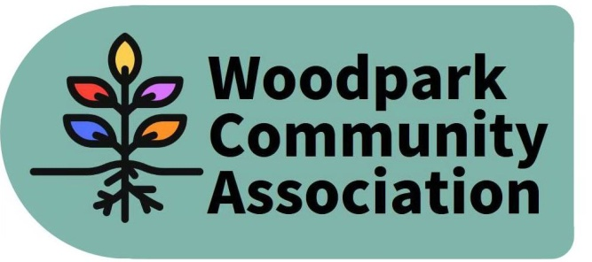
Attendees: Ian McCallum, Robert Hunter, Stephen Kassner, Larry Ladell, Tom Marcantanio, Sue Milburn-Hopwood, Jennifer Plank, Don Wood

Absent: Tanya Krupinicki, David Levesque

1 | Discussion with Anita Vandenbeld, Member of Parliament for Ottawa West-Nepean – Anita Vanderbeld was unable to attend due to a last minute scheduling conflict. The committee will invite her to attend in early 2022. Community member Nancy Dale asked to be advised when the meeting with our MP is rescheduled. (ACTION ITEM FOR SECRETARY)
2 | Call to order  Communicated absences: Tanya Krupilnicki, David Levesque  Addition/Deletions to the agenda: The issues of 1) recent break ins and 2) the Carling Woodroffe intersection were added to Agenda Item 6 .  Review of October Minutes and Action Items – The Minutes were approved with a few small changes.
3 | President’s Update  Follow-up from discussion with community members at October meeting - Ian noted that the two residents with the drainage issue have had discussions with KEV. Work is also underway to address the parking issue at the west end of Lawn and potentially part of Edgeworth.  Official Plan – The city council has approved the Official Plan. The enabling bylaws will be presented in the spring.
3 | Committee Updates  Sustainability - David Levesque will be the chair of this committee. There have been no recent meetings.  Internal Services  -The current balance of the WCA account is $2,025.91. The Association has received the reimbursement for the mural supplies. $39 was received from a resident’s book sale. The pumpkin sale netted $70 dollars. It was agreed that $50 would be spent for reimbursement for the use of the leaf shredder used at the park clean-up.  -There was a discussion about the transparency on the work of the WCA. There is a need to update the WCA webpage to include minutes of recent meetings. (ACTION ITEM FOR INTERNAL SERVICES SUBCOMMITTEE)  -There was also discussion about the methods the Board uses to communicate with Woodpark residents (email, website and Facebook), need to more actively use the website and to link the WCA’s Facebook postings to the website. Ian agreed to write a monthly update to post on the website and to discuss the more deliberate use of the website with David (ACTION ITEM FOR CHAIR AND CHAIR OF INTERNAL SERVICES SUBCOMMITTEE).  -Ian also offered to develop a QR code poster for sites around the neighbourhood which would allow Woodpark Residents to easily sign up for the email distribution list and the Woodparkers Facebook Group. (ACTION ITEM FOR CHAIR)  Infrastructure & Development - Ian reported on planned 5 story development at Bromley and Carling (1983 Carling) that meets current city development guidelines. He also reported on the proposed redevelopment for 1071 Ambleside. This proposed 30 storey apartment building is the first development under the Clearly New Orchard secondary plan and therefore worth following. There was also discussion about the sale of 2304 Midway and implications for the neighbourhood if these large lots on Midway are fully developed with 613 flats. Ian indicated that he would write to Councillor Theresa Kavanagh to raise the Board’s concern about overdevelopment in the area and possible restrictions. The Board supported such a letter. (ACTION ITEM FOR CHAIR)  Outreach & Events  - Oct - Park Clean Up/Pumpkin event – Both events were a success. There was some discussion about the competitive nature of the pumpkin carving contest. The Events committee was asked to look at some options for a different approach next year which might better balance competition with participation (ie possible a combination of voting and draws to determine prize allocation). (ACTION EVENTS SUBCOMMITTEE CHAIR)  - Nov - Lantern Walk – The Lantern Walk is scheduled for Nov 13 – rain or shine. Available Board Members and Volunteers are asked to meet at 4 oclock in the garden to organize set up.  - Dec - Holiday gift giving – Planning for the Holiday gift giving initiative is well at hand. Flyers describing the initiative and seeking community participation will be distributed during the week of Nov 14. Larry will be seeking assistance from Board Members to deliver the flyers. The gifts will be presented to the Administration at the New Orchard Lodge on Thursday Dec 16 at 2 pm. Board members are encouraged to attend.  - Opportunity for communication to Woodpark Residents – A short message to Woodpark residents updating them on recent accomplishments and seeking volunteers for the WCA board, subcommittees and projects/events was distributed to the Board for comment. This message will be included in the flyer distributed to the community to advertise the Holiday Gift Giving event.
6 | Other items:  Recent Break ins – There was a discussion about recent break ins in Woodpark and what to do about the issue. It was agreed that we should invite the Ottawa Police Community Safety Officer to the December meeting of the Board (ACTION ITEM FOR CHAIR/SECRETARY). It was also suggested that the WCA could publish some Tips for residents about preventing and reporting on thiefs/break ins (ACTION ITEM FOR INTERNAL SERVICES SUBCOMMITTEE).  Woodroffe/Carling Intersection – Don Wood asked whether it would be prudent to reinvigorate the coalition of community associations concerned about that intersection given expected increased traffic when workers return to their workplaces and more buses pass through the area. Ian will contact the other nearby community associations to determine the interest in reinvigorating this work. (ACTION ITEM FOR CHAIR).
7 | Adjournment

Next Meeting – Wednesday December 8, 2021 – 7 pm

Forward Agenda
-Review of Terms of Reference for each of the subcommittees
-Update from KEV/City on LRT activities in neighbourhood
-Meetings with Jeremy Roberts, Theresa Kavanagh, Anita Vandenbeld
-Discussion with Chairs of Neighbouring Community Associations on their priorities and identification of common interests

