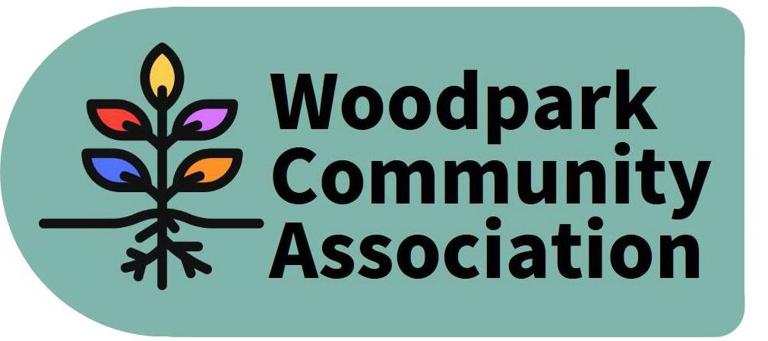
Monthly Meeting – 7 pm, November 18, 2020
MINUTES
Meeting held via ZOOM. Minutes taken by Larry
Present: Ian, Stephen, Erica, Celeste, Rob, David, Jessica, Larry
Absent: Don, Tom, Tanya
Guests: Sue Milburn-Hopwood, Andrea Ward
- Agenda with additions was approved.
- October Minutes deferred.
- President’s Report – Ian discussed the following matters: Increased parking planned for Byron, Nov. 12 Ward Council meeting, community policing, Britannia Winter Trail, proposed Bayshore high-rises, Stage 2 construction, community art for LRT Stations, tree replacement plans. He is considering seeking community input with regard to the proposed parking plans for Byron. The proposed 10-plus parking spaces seems excessive for the pick-up and drop-off needs of Woodpark residents at New Orchard Station and this could attract outside and overflow traffic from Lincoln Fields Station. Moreover, such parking represents a significant loss of green space.
- Treasurer’s Report deferred.
- Report on Workshop – Ian submitted an action report (copy attached) on the Community and Board workshops which the Board requested to be posted on the WCA web site. Erica, Jessica and Stephen undertook to move forward with reorganizing the Board’s committee structure.
- Sue, Andrea and David presented plans for a gift exchange in the community. It was decided that Andrea and Sue would produce a newsletter to encourage participation. Larry would help organize its distribution.
- David provided an update on the Pet Photo contest. Prizes have been donated.
- David provided a debrief on the Park Cleanup, Pumpkin Sale and Pumpkin Carving and Yard Decoration Contest. The park cleanup filled 64 leaf bags while the pumpkin sale was a successful fundraiser.
- In Tanya’s absence, the discussion of future meeting space was deferred.
- Larry discussed the possibility of a potential dog park/run/off-leash area on the contaminated lots at the southwest corner of Richmond and Edgeworth. He advised that he is consulting with the Councillor and will discuss the proposal with adjacent neighbours. Andrea undertook to assist him with advice.
- With regard to Walsh Ave. traffic concerns, Rob spoke with Councillor Kavanagh’s office and confirmed that the City will proceed with the “bulb-out and delineator” option as a traffic calming measure.
- Celeste reported that there is no news with respect to the 2175 Carling Colonnade BridgePort development and community parkette.

There being no further business, the meeting adjourned. The next meeting is scheduled for December 9 via Zoom.

ATTACHMENT: Ian’s Workshop Report

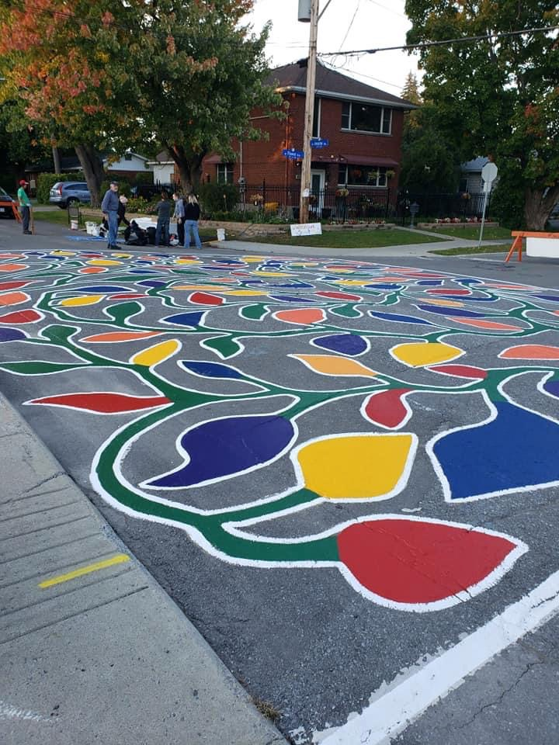

Woodpark Grows Forward:

Woodpark Community Association Board action plan
DRAFT 1: NOVEMBER 3, 2020

Introduction

Context for discussion and overview of process
The Woodpark Community Association Board launched a participatory process in August 2020 designed to learn about, connect with and hear from community members about their concerns, hopes, ideas and suggestions for the community. The Board had set a goal to improve community engagement, community building and communication so it could better serve and be of service to the community overall.

A virtual workshop was held with community members on Thursday Sept 8 to review the issues facing the community and the future vision of the community. The group used a virtual post it note system to identify a number of opportunities and challenges and then moved into two breakout groups to focus on two priorities each. Both groups chose to discuss intensification and traffic.

The concern with intensification was driven by the loss of smaller traditional homes in the community and being replaced with new larger semi’s at ever increasing prices. Intensification around the perimeter of the community is seen as a challenge due to minimal public space with more people living in the community. Finding ways to increase access to public spaces and increase involvement with community are potential mechanisms to build a stronger community.

A survey was conducted with community members in September covering a nearly 3-week period prior to the Virtual Workshop. Community members were invited to participate in the survey via FaceBook post, WCA email blast and by shared links by Board members. Forty-five unique responses were recorded. There were 37 questions, 19 (or half) of which asked for people to express interest in possible projects or ideas for the Woodpark Community Association. Below is ranking of those survey questions.
“ It’s a quiet community, without much through traffic. It’s near the River and within walking distance to Mud Lake, and to the Woodroffe lookout at the River. All the services I need are with walking distance to my home.
“Important to note that although traffic is a concern, my primary concern is not limiting the number of vehicles accessing the region, but rather ensuring that those vehicles can effectively navigate the area without excessive impediments (speedbumps, extra lights/ signs, lane reductions).
“…You need to do advocacy, but also communicate with and involve the rest of us.”
“Maintain the spirit, commitment and warmth you have now in your neighbourhood by bringing people into the association.”

Survey Priorities
Priorities | Issues | Score | Indeciveness / neutral
1 | Traffic in the neighbourhood | 71 | 1
2 | Impacts of light rail transit (LRT) construction | 70.5 | 2
3 | New developments in the neighbourhood | 65 | 4
3 | Planting of native trees in the neighbourhood | 63 | 3
4 | More useable green space in the community | 61 | 4
5 | Traffic Woodroffe Carling corridor | 56 | 9
6 | New developments surrounding the neighbourhood | 46 | 6
Middle 1/3
7 | Events and activities for youth | 43.5 | 8
8 | Community centre we can walk to (with community kitchen, tool library, meeting space, woodshop etc) | 40.5 | 7
9 | New sidewalks | 39.5 | 10
Half way
10 | Walkable pub | 38.5
11 | Better integration of community & schools (eg. using space) | 37.5 | 14
12 | Carlingwood mall construction | 32.5 | 8
Bottom (1/3)
13 | Design and decoration of LRT station | 30 | 17
14 | Food security - can we grow more food in Woodpark? | 25.5 | 7
15 | Assist neighbours with impacts of climate change | 23.5 | 19
16 | Recycling neighbour’s metal waste | 23 | 21
17 | Expansion of community space at the library | 19 | 14
18 | More flexible library hours | 14.5 | 12
19 | Woodpark Orchestra | 1.5 | 23

The score was created using 2 points for very important, 1point for important, a -0.5 for not important. Scoring the not important as a-0.5 treats the issue of resistance to the idea while not cancelling out someone else’s position. The tallying of unsure, need more info and non-responses was created because a number of ideas were responded to in a neutral manner. In some cases, participants were not prepared to express an opinion; perhaps they need more information or engagement with the idea.

Members of the Woodpark Community Association Board gathered on Sept 20th to review the community input, offer their own ideas, hopes and suggestions and craft the input into a draft plan of action for the next few years. This report provides a summary of the Board’s deliberations and its draft plan for Woodpark Grows Forward.

Step 1: Welcome and working together

How we work together is as important as what we work on
The majority of the WCA Board gathered virtually on the morning of Sunday September 20th to begin the process of creating a plan for where they would focus their volunteer efforts and energy on behalf of the community.

When asked “What is needed from everyone for an effective, collaborative working environment?” Board members responded:
- Different members have different goals and that’s OK
- Brief, concise answers
- Space and time to listen and process
- Open conversation
- Space to hear different voices
- All voices heard – including those who are quiet and reserved
- Work from our strengths and interests to make a contribution (which means we need to get to know each other better) x2
- We solicit everyone’s opinions, not just the 3 or 4 people who chime in
- Identifying strengths so we can allocate our resources and who does which task – be able to tap those skills
- Keeping everything “above board” – open, not personal, not negative, respectful
- Frank (and respectful) – be willing to hear each other and willing to speak your mind
- Be a little more focused and less reactionary, maybe we have more committee meetings (quarterly?) rather than full board agendas
- Follow-through – move beyond ideas to getting things done
- Step back on occasion and look at the big picture and review wins and losses to make a plan for the future – mix both social & CA activities
- Leverage committees so people can contribute more
- Have committee members be community members and Board members lead or participate in committees (committees can decide their structure)

The Board hopes to use this list to refer to when they begin meetings or work together on initiatives.

Step 2: Reflecting on community input

Thinking about community needs to ground our discussion about the action plan
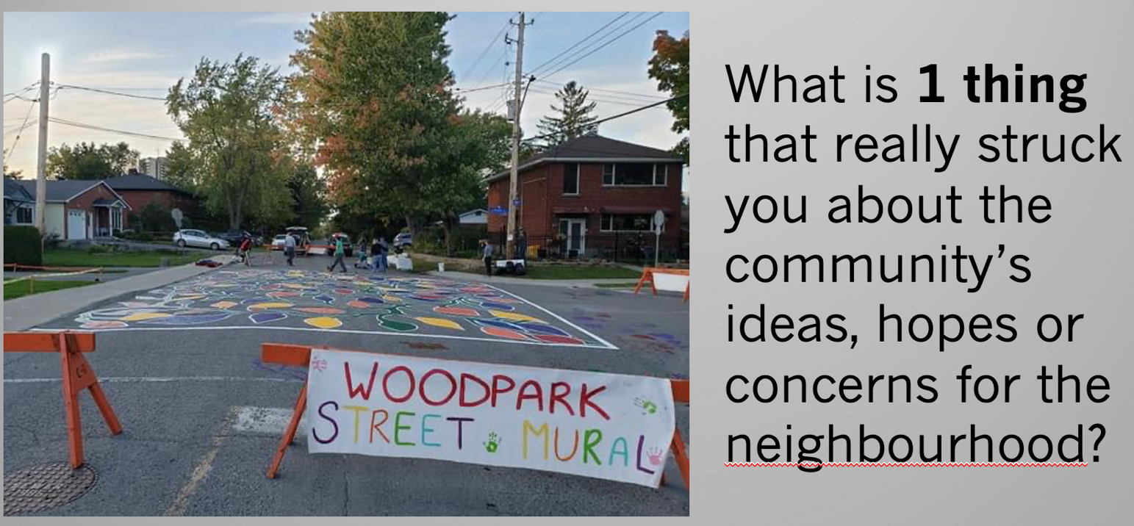Participants were asked to reflect on the results of the virtual workshop and survey and identify what really stood out for them about the input. Board members offered the following:
Yes!
- There is a deep appreciation for this community.
- Many of those who participated in the survey had not previously been involved with the WCA – that’s a good thing!
- People gave us so many ideas – tree planting, traffic management, additional community events to bring people together and so much more.
So true!
- Address traffic issues from development and light rail and ease the negative impacts of construction.
Agree
- Some community members have had negative experiences with WCA in the past and raised concerns about transparency and integrity. We need to address those perceptions and create a different environment.
- Some community members feel like only a small group of people are heard.
- We need to advocate better with City hall on behalf of the community – we are always reacting to bad news rather than being proactive about what we want.
- People want more green space, dog parks, access to public recreation.
- Some people are worried about crime and safety and many are concerned about development.
- A few people indicated they wanted to get involved on specific events or projects rather than serve on the WCA Board but couldn’t find a way for them to play that kind of role.
- People advocated for green space, public transit, and events for kids.
- Be sure to look at initiatives from different viewpoints (i.e. young families, business professionals, retirees etc.)
- People want better and more communication.
- The community is feeling the tension that comes with change and growth – construction, traffic challenges, infill development and more.
Agree
- We need a thorough review of the 20 priorities we asked people to comment on so we can figure out how to work on the top priorities.

Step 3: WCA Board ideas and hopes

What are your biggest hopes and ideas for Woodpark? What do you want to create?
Board members were asked to think about what motivated them to volunteer on the WCA and to consider what positive contribution and impact they want to have in their community. Participants brainstormed a variety of ideas, noted below.

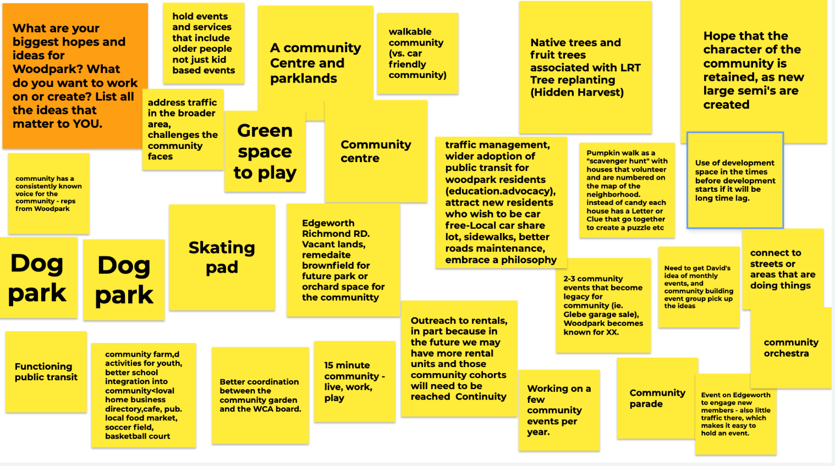

After the group brainstorm, participants then discussed how their ideas aligned with or diverged from the input of the community, considering how to ensure that community member’s input be included in the action plan going forward.

There was significant discussion on HOW to better engage people and create opportunities for people to get involved in specific projects, programs or initiatives. The Board identified the need to review its committee and working group structure, and to identify plans to recruit community members to participate in ways that work best for them.

Step 4: Creating an action plan

DRAFT 1 of participant responses, insights and ideas

If everything is a priority, then nothing is a priority
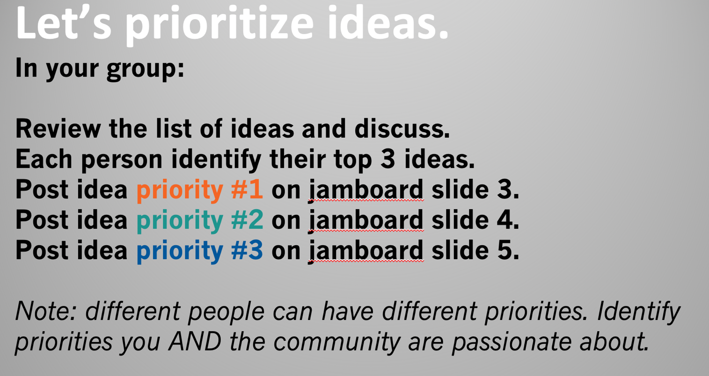

Board members were asked to consider the realities of their volunteer roles, the other priorities in their lives and the available time, energy and interest they had available for WCA activities.

The table below lists the action items identified. After identifying ideas, Board members were then asked to put their names on the priority items they were prepared to work on and make real.

Action Priority #1 | Action Priority #2 | Action Priority #3
Community input and improved governance  - Giving larger role and direction to committees to have them step up and meet - Jessica  - Having a voice to speak for the whole committee to the rest of the board  - Delegation – who will give orders and who feels comfortable to accept?  - Review and rationalize committee structure – Stephen, Jessica, Ian | Governance  - How to empower a committee to speak up if not all are unified. The voice may be speaking up to the City about what the “we” wants, yet it only represents a smaller portion of everyone’s voices.  - Focusing board meeting time on timely events such as monthly meetings to focus on the relevant upcoming projects (for example the last meeting could have focused more on the mural event etc) - Ian | Community Outreach and participation  - Accessibility to CA information and reaching those who are not on facebook – Tom, Ian  - Phone tree or contact with a WCA Board member to do interviews, block captains - Tanya  - Outreach to renters and condo owners – Larry
Community events  - Ongoing community event schedules for members of the community - Jessica | Community events  - More fun events create stronger community connections – Tanya, Jessica, Larry, Stephen  - Community festival with parade and picnic – Tom, Larry, Tanya  - Events – the chili cook off was well received by older community members (also food is COVID dependent) - Jessica  - More community events – Ian | Events focused on seniors or various age ranges – Jessica
Community Centre  - Community / Farm Centre – Tom, Ian  - Getting the Edgeworth / Richmond Road parcels converted into useable greenspace and/or a potential recreation centre and/or dog park – Ian, Larry, Tom, Stephen  - Community centre (maybe on church property?) - Larry | Traffic and development around the neighbourhood - Ian | Community integration with schools - Tom
Walkable 15-minute community - Celeste | - Dog park or activities  - Limited sidewalks to support LRT or gateway to community

Board members identified that the next steps to completing the action plan would include:
- Getting the input of Board members who were not available to participate in the meeting
- Putting some timelines on priority action items, and identifying next steps and to do lists
- Going back to the community to gather their input and feedback on the draft plan, and adjusting the plan based on the input
- Recruiting community members to participate in initiatives
- Adjusting the committee and Board governance process

