WCA Monthly Board Meeting  Wednesday September 15, 2021  7:30pm  Via Zoom |  | 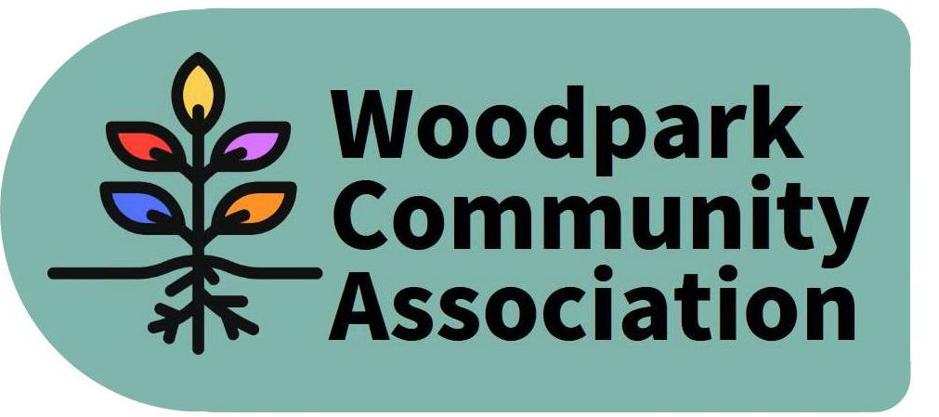
Attendees: Ian McCallum, Robert Hunter, Stephen Kassner, Tanya Krupinicki, Larry Ladell, David Levesque, Sue Milburn-Hopwood, Jennifer Plank, Don Wood

Absent: Tom Marcantanio

1 | Call to order  Communicated absences: Tom Marcantanio  Additions/Deletions to the agenda: none
2 | President’s Update  Ian indicated that the community association to the west has been disappointed that the developer for the Lincoln Heights Mall redevelopment has not been required by the City to develop a secondary plan. A Letter to the Editor on the issue was drafted but it is unknown whether it was ever finalized and published. Ian indicated that if the Official Plan passes this fall, a secondary plan will not be required but there may be new requirements for the developer.  Final version of Official Plan will be discussed and likely approved by Council in the coming weeks. Some changes were made to the plan to reduce density within neighbourhoods and allow bigger towers near arterial roads.  Ian has talked to Damon Berlin from the City about replacing missing turning restriction signs at Richardson and Richmond Road and the status of the Edgeworth Ave work.  City is struggling to deliver services given COVID situation. As an example the city has lost 6 arenas that have been used as COVID centres.  Construction has begun on the New Orchard Station House at the bottom of Woodlawn. Other parts of the construction along Byron seem to be moving more slowly and it is expected that construction will continue for many more months.  Low speed signs have been painted on Walsh and flex signs has been installed.  Trish Ross is stepping down as the President of the McKellar Heights Community Association.  Sue raised the need for the WCA to determine its priorities and to start to advocate for them with local politicians and the city. Ian indicated that there was an initial priority setting process undertaken a couple of years ago and that we should update that. David raised the need to consult with the community on the priorities. Ian committed to circulating the initial priorities document and offered the services of his wife who is a consultant with relevant expertise to work with Sue to help develop a process for revising our priorities and consulting with the community. ACTION – IAN TO DISTRIBUTE PRIORITIES DOCUMENT. SUE TO DEVELOP PROCESS FOR DISCUSSION BY THE BOARD.
3 | Committee Updates  Environment & Sustainability  Sue indicated that Graham MacDonald and Kate Punnett have resigned from the Sustainability Subcommittee and Stephanie Trottier has expressed interest in becoming a member. Current project ideas being developed include tree planting, energy audits and community composting. Other ideas include beekeeping and working with local gas stations for electric vehicle charging stations. There was discussion about the need for community bulletin boards to promote the work of the Sustainability Community in key places in the neighbourhood (such as end of Lawn and end of Ancaster) and it was agreed that we would add this idea to the priorities list. ACTION: SUE TO ADD COMMUNITY BULLETIN BOARD TO LIST OF PRIORITIES.  Internal Services  David asked that there be a vote to approve the purchase of a Zoom Account for the WCA. Following a vote the purchase was approved. David will set up the account and provide all WCA Board members with the password in late September. ACTION: DAVID TO SET UP ZOOM ACCOUNT.  Infrastructure & Development  The subcommittee has not yet met but Don committed to get it up and running in the coming weeks and develop a Terms of Reference based on the model used by the other subcommittees. ACTION: DON TO ORGANIZE FIRST MEETING OF INFRASTRUCTURE AND DEVELOPMENT COMMITTEE AND DEVELOP TERMS OF REFERENCE.  Outreach & Events  Tanya reported that the mural painting event was another success. The Board thanked Tanya for her work.  David has agreed to lead the organization of the park clean-up and pumpkin sale/craving contest. This will take place on Oct 23 (raindate Oct 24). It was agreed that Canadian Tire would be approached to provide bags for the clean up.  The November event will be the Lantern Walk. It is hoped that Kate will continue to be involved in it.  The December event will be a gift collection for a local long term care facility.
4 | Treasurer’s Report  Tanya reported on the status of WCA bank account. The current balance is $1148.94. Donations totaling $39 were received during the mural painting event. There will be $2,173.41 in the account, when the City reimburses the WCA for the painting and other supplies for the mural painting.
5 | Board Administration  Both Kate Punnett and Erica Dath have resigned from the Board. The resignation of Erica Dath means that the position of Board Secretary is vacant. Sue Milburn-Hopwood agreed to take on the position of Board Secretary. Larry Ladell agreed to take on the role of Chairperson of the Outreach and Events Committee replacing Sue.  There is a need to recruit additional members to the Board. David Levesque agreed to draft a note that could be distributed to the community via Facebook and other mechanisms to recruit new members for both the Board and various subcommittees. ACTION – DAVID TO PREPARE NOTE FOR DISTRIBUTION TO COMMUNITY VIA FACEBOOK AND OTHER MEANS SEEKING ADDITIONAL MEMBERS TO BOARD AND ITS SUBCOMMITTEES.
6 | Other items:  - Approval of July Minutes – these were approved with a small change to the Outreach and Events Subcommittee report to include the October Park Clean Up/Pumpkin Sale/Contest.  -It was suggested that the neighbouring community associations be invited to an upcoming meeting to discuss the LRT issues and other issues in common.
7 | Adjournment

Next Meeting - October 13, 2021 7:00 pm

