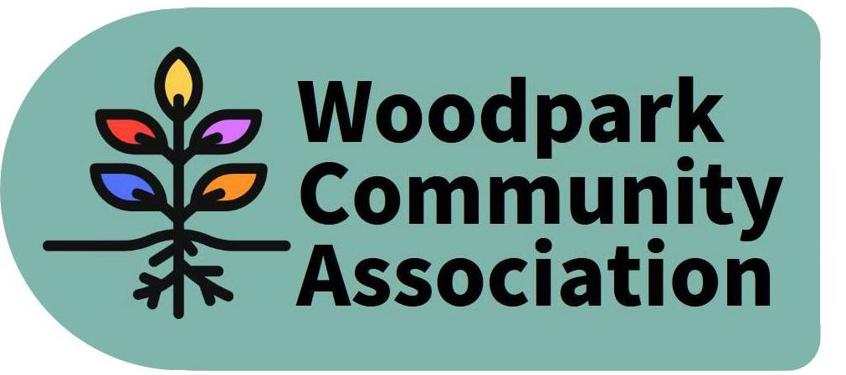
Monthly Meeting – 7 pm, January 13, 2021
MINUTES
Meeting held via Zoom. Minutes taken by Larry
Present: Ian, Erica, Celeste, David, Don, Rob, Tom, Larry
Absent: Jessica, Tanya, Stephen
Guests: Councillor Theresa Kavanagh, Connie DeFalco, Andrea Ward
- In view of the Councillor’s attendance the Agenda was amended to add her remarks after the President’s Report.
- December Minutes were approved.
- President’s Report – Ian thanked Andrea, Sue and David for their work on the Gift Exchange Project. It appears that Byron will remain closed until March. Meanwhile there is a problem with parking on Byron obstructing the work area and vehicles having to regularly drive over the sidewalk. There is also a problem with errant dump trucks driving through the community to the wrong location and then having to back up for extended distances. Ian has been unsuccessful in obtaining hard copies of the draft Official Plan. Only 7 or 8 copies are available at the main library for the entire city. The City is not facilitating much meaningful public input. The Federation of Citizens’ is holding workshops on the plan on Jan. 23 and 30.
- Councillor’s Remarks – Theresa reported that the City is getting ready for Phase 2 of Covid vaccinations. She is anxious that these clinics be located in non-car dependent locations accessible to lower income residents. Theresa indicated that Stage 2 representatives would be attending WCA’s February meeting to report on LRT construction and address community concerns. As for the problems with trucks, she urged people to document problems and call 311 with the information. With limited resources, more complaints equal response. As for traffic calming, Theresa said that painted bump-outs with flex sticks have proven quite effective on Knightsbridge and Iroquois as a low-cost option. Walsh will be done in the spring. Other streets will need to wait for the next budget. Speed bumps are too expensive, dangerous and noisy for most Woodpark streets. Meantime she has some “Slow Down For Us” signs available.
- Reorganization - Erica submitted a revised list of 4 committees. Each committee now needs to elect a chair and lead and to draft a description of its mandate before the next meeting.
- Winter Picnic – David advised that in view of the lockdown, it has been cancelled.
- Maintenance of NCC Lands – Tom requested that the Board circulate on its listserv a petition to the NCC requesting that the 1-acre parcel east of the transit station in southeast of Lincoln Fields be reclassified from Category 4 to 3 so that it is maintained for public use. He volunteered to do the work necessary to make it useable. The Board approved an email inviting people to sign his petition.
- Snow Moles – Celeste reported that this was an initiative by the Council on Aging to gather information on accessibility to submit to the City.
- Gift Exchange – David and Andrea reported that the collection of gifts for Carlingview Manor has been a huge success and that it has spawned other initiatives to support residents. Currently they are collecting old Ipads to distribute.
- Draft Official Plan – Ian has been unable to obtain hard copies of the draft document. Approximately 8 copies were given to the public library for viewing but these are now inaccessible because of the lockdown. The Federation of Citizens Associations is giving workshops on the plan on Jan 23 and 30 and Stephen, Celeste and Larry are invited to attend. The deadline for public comment is early February.
- In Tanya’s absence the Treasurer’s Report was deferred.
- Lincoln Fields Area Planning Study – As noted earlier, a group meeting was held in December to relaunch this study. We are awaiting notice of further meetings with the City planner and community groups to get a sense of where/how this study is proceeding. In the meantime, Ian stressed that it is important to be conversant with the implications of the new Official Plan.
- Dog Off-Leash Area – Larry indicated that he has yet to contact neighbours on Edgeworth to solicit their support. Mea culpa!
- Sabbatical – Tom indicated that he was taking leave from the Board until such time as we can begin holding in-person meetings again.
The meeting adjourned to an informal session. The next meeting is scheduled for February 10 via Zoom.

