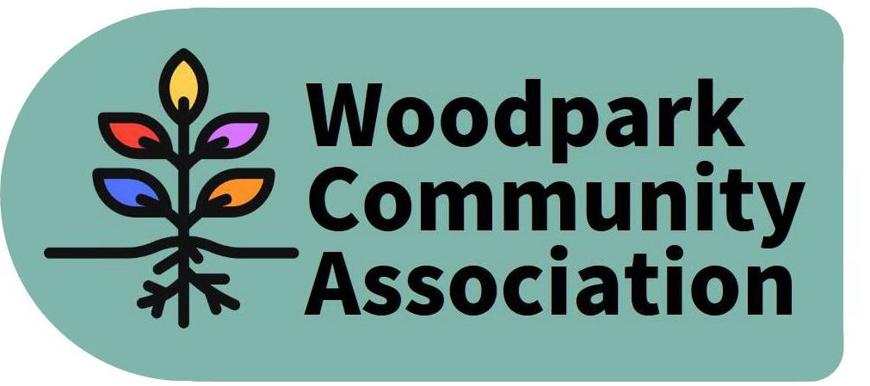
Monthly Meeting – 7:00 pm, April 14, 2021
MINUTES
Meeting held via Zoom. Minutes taken by Larry
Present: Ian, Stephen, David, Don, Tom, Rob, Tanya, Erica, Larry
Absent: Jessica
Guest: Stephanie Kajenski
- The Minutes of the March meeting were approved.
- President’s Report – Ian noted that we were unclear where our Councillor stood with respect to our comments on the Official Plan. Meantime Councillor Jan Harder has expressed general support. Some concern had been expressed about keeping the toys in New Orchard Park sanitized. Meanwhile it appears that they have all since disappeared. Ian is preparing a community newsletter and will seek input from the Garden Committee. Ian proposed organizing a river cleanup in June.
- Internal Services Committee – The WCA web site is now co-managed by David and Tanya. Tanya reported that our account balance was $1567.41 and thanked Tom for his fund-raising activities.
- Outreach and Events Committee - The park cleanup was scheduled for April 24 and an e-blast and posting on Woodparkers FB page was to be done. (This event was subsequently cancelled by the provincial lockdown.) Rob volunteered to pursue the idea of establishing a dog run that was discussed last fall. Larry has agreed to seek community support for it through the Newsletter.
- Infrastructure and Development Committee – Stephanie Kajenski spoke to the Board about concerns regarding an ongoing construction project at 451 Ancaster. The property has been in transition for some time and no signage has been posted. Don undertook to follow-up this matter with the by-law office. Ian reported on an upcoming variance request for 2250 Midway. The owner is seeking to construct a shed larger than allowed under current zoning. No particular concerns have been identified. Don reported on his efforts to confirm previous understandings with respect to the design of the New Orchard LRT Station. The community and WCA Board had invested considerable time and effort in arriving at a suitable plan which with the passage of time and changes in key actors has become confused. Don has been working with Damon Berlin to confirm that the previous understandings would be honoured. The final design for Byron Park will be completed in October and no further input from the community will be sought. WCA wants to ensure that trees and not a parking will be the priority. Don learned that there had been further tweaks to the design of the Lawn Parkette. An unexpected bonus is that KEV will be addressing drainage problems for the rear yards of properties along Edgeworth. Don noted construction workers for the Azure development were parking in the neighbourhood. He warned several of them about leaving garbage behind.
- Environment Committee - Ian undertook to organize the Ecology Ottawa Tree Giveaway for May 15. (This event will now need to be re-scheduled or cancelled.) Tom is still working on getting the NCC to maintain the orphaned land south of the community garden.
The meeting adjourned. The next meeting is scheduled for 7 pm May 12 via Zoom.
ADDENDUM – Ian requested that the Minutes note that he had sent a letter of support on behalf of WCA to the Mayor concerning a homophobic incident in the neighbourhood.

