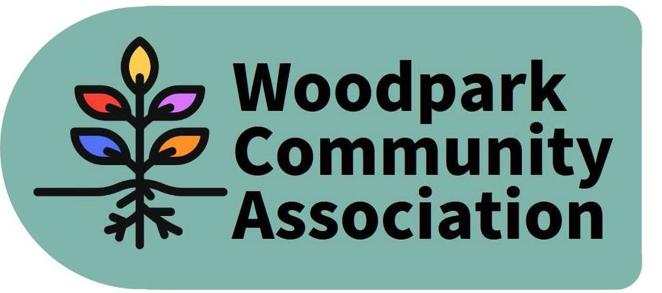
Monthly Meeting – 6:30 pm, February 10, 2021
MINUTES
Meeting held via Zoom. Minutes taken by Larry
Present: Ian, Erica, Stephen, David, Don, Jessica, Tom, Tanya, Larry
Absent: Celeste, Rob
Guests: Councillor Theresa Kavanagh, Damon Berlin (Stage 2), Rosanna Baggs (Stage 2), Ed Neuman (KEV), Jamie Robinson (KEV), Jennifer Falconer (KEV), Sue Milburn-Hopwood and approximately 30 residents of the Woodpark community.
- The meeting started pending the arrival of guests from the City’s Stage 2 office and KEV (Kiewit-Eurovia-VINCI) Consortium.
- January Minutes were approved.
- President’s Report – Ian began by discussing the draft Official Plan and its potential impacts on Woodpark. For summaries and feedback see: https://engage.ottawa.ca/the-new-official-plan/news_feed/one-pagers-and-feedback-forms
- Stage 2 and KEV Presentation – The presentation and Q & A session will be posted to the woodpark.ca web site. Highlights include the following:
- The consortium is allowed to work between 7 am and 10 pm and additional night work as necessary.
- Noise levels are being monitored on a continuous basis and remedial action undertaken as required.
- Construction is scheduled to end in the fall of 2025.
- The Consortium will undertake to produce 90-day look-ahead reports starting next month and each quarter thereafter.
- There is approximately 2 more metres of rock to excavate along the Byron Richmond Road right-of-way. Blasting is not allowed for much of the route.
- Sewer work on Edgeworth, north of Lawn is scheduled to begin in April.
- The Councillor is planning to host informal coffee sessions to give KEV an opportunity to meet with the community.
- The final design for the Byron Park has not yet been completed.
- President’s Report (continued) – Ian continued his discussion of the draft Official Plan. The most impactful aspect for Woodpark is the City’s promotion of “613” (6 rooms including 1 bathroom and 3 bedrooms) apartments within established neighbourhoods. This could result in new 4-storey developments along with the continued building of semis. This will not leave much space for trees. In addition, the Transportation Master Plan is expected shortly and will have further implications. Erica indicated that Carlingview Manor will be moving and more development along Carling is imminent. Larry pointed out that Secondary Plans such as the one for Lincoln Fields will trump whatever is set out in the Official Plan. Erica, Stephen and Larry agreed to consult with Ian to draft a WCA response to the plan before the end of February to accommodate the March 12 deadline for comments.
- Report of the Internal Service Committee – David was confirmed as Committee Chair. He will help draft its mandate, its goals and objectives and a call to action for the community. Larry undertook to compile a list of community volunteers.
- Report of the Outreach & Events Committee – Larry and Tanya will co-Chair this committee. The committee will work to produce its description details and plans for the next meeting.
- Report of the Infrastructure & Development Committee – Don and Ian will co-Chair this committee. Details to follow.
- Report of the Environment & Sustainability Committee – Ian and Tom will work to clarify the committee’s mandate. Ian is looking to organize a tree giveaway during the Spring Cleanup.
- Other Business
- Tanya reported our bank balance was $1651.69
- The Board approved $25 to David to assist with paying for his Zoom subscription.
- The AGM was tentatively scheduled for May 19.
The meeting adjourned at 9 pm. The next meeting is scheduled for 7 pm March 10 via Zoom.

